

Capstone Project Phase A
Attenglish: English Learning Mobile App for ADHD Pupils
25-2-D-16
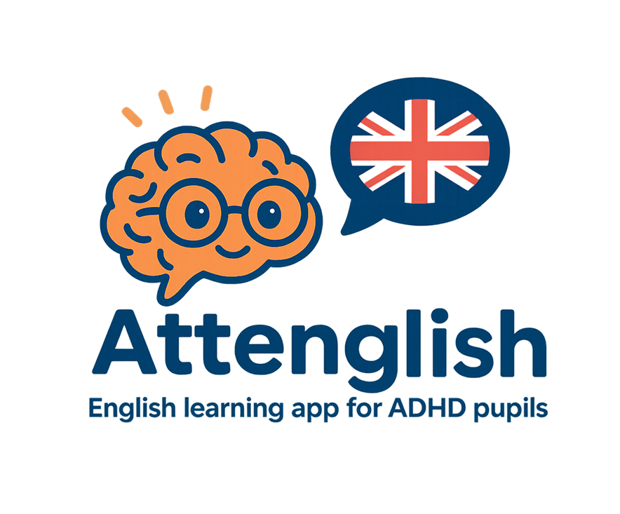

Final Project By:
Kfir Amoyal
Omri Heit

Advisor:
Dr. Natali Levi

Table of Contents
1. Introduction 3
2. Literature Review 4
2.1. Experiences of Students with ADHD Using 3D, Haptic-Enabled Virtual Reality 4
2.2. Practical Strategies to Assist Children with ADHD in the Classroom 5
2.3. Gamified Mobile‑Technology Interventions for ADHD Learners 6
2.4. Managing ADHD Symptoms in Children through Technology‑Driven Serious Games 7
2.5. Executive-Function and Working-Memory Training Apps 8
2.6. Parent‑Engagement & Home–School Data Loops 9
2.7. English Studies in The Israeli Education System 10
3. Expected Achievements 11
4. Engineering Process 12
4.1. The Process 12
4.2. The Product 13
4.2.1. Functional Requirements 15
4.2.2. Non-Functional Requirements 16
4.2.3. Use-Case Diagram 18
4.2.4. Class Diagram 19
4.2.5. System Architecture 20
4.2.6. Front-End UI Concept 20
5. Quality Assurance and Testing Plan 21
6. References 23
7. Appendix 24
7.1.1. Interview With Keren Yerushalmi 24
7.1.2. Surveys Results 27

Abstract
Attention-Deficit/Hyperactivity Disorder (ADHD) is increasingly prevalent in classrooms worldwide, posing significant challenges to both students and educators [1]. These challenges stem from core ADHD symptoms - impulsiveness, inattention, and hyperactivity - that interfere with traditional methods of language acquisition. Attenglish is a specialized mobile application designed to meet the unique needs of ADHD learners in elementary to high-school settings.
By leveraging interactive modules, adaptive pacing, and evidence-based teaching strategies, the app seeks to boost engagement, bolster linguistic confidence, and provide real-time feedback to pupils, teachers and parents. Attenglish offers not only effective language instruction, but also the tools for continuous progress monitoring, facilitating tailor-made interventions. As part of a broader inclusive education approach, this book presents how Attenglish addresses core ADHD learning gaps, lays out the engineering and testing processes, and positions the technology as a vital tool for teachers aiming to support ADHD pupils in mastering English.

Introduction
Learning English as a second or foreign language can be complicated for most lower-education pupils, but the process becomes particularly challenging for K-12 pupils diagnosed with ADHD. Research indicates that children with ADHD often experience significant delays in reading proficiency, with approximately 30% showing notable challenges in reading and
writing [2]. These difficulties stem from core issues in sustaining focus, decoding language structures, and maintaining motivation over time.
While many existing language-learning platforms offer gamified lessons and interactive modules, few specifically address the unique challenges faced by ADHD students. Studies have shown that game-based learning can benefit students with ADHD by enhancing engagement and focus [3]. However, such strategies often lack adaptive technology capable of capturing data on attention spans, task completion rates, and progress markers.
Attenglish, the mobile application central to this project, integrates core elements of ADHD-friendly instruction - immediate AI-powered feedback, gamified interactions, and systematic skill reinforcement - into a cohesive ecosystem. The program employs branching pathways to accommodate different pacing speeds, frequent pop-up reminders to maintain attention, and brief, skill-specific games designed to enhance both vocabulary and grammatical fluency. These features are supported by AI-based data-tracking mechanisms that allow educators to identify stumbling blocks swiftly and provide targeted guidance.​
Parents stand to benefit significantly from Attenglish by gaining clearer insight into their children’s language-learning trajectory. School administrators can leverage aggregate data for decision-making related to curriculum design, student placement, and resource allocation. Moreover, the seamless integration of Attenglish into established classroom routines has the potential to reduce the stigma often associated with ADHD learners, promoting a more inclusive environment where they can thrive.​
This book is structured to guide the reader through multiple facets of the Attenglish project, segmenting the project's process into chapters:
- Literature Review delves into contemporary understandings of ADHD, language acquisition, and current technological solutions, highlighting the essential principles behind effective interventions.
- Expected Achievements outlines specific academic and behavioral milestones that Attenglish aims to fulfill, backed by measurable success criteria.
- Engineering Process details the iterative design cycle, covering everything from initial conceptual modeling to usability tests conducted in real classrooms.
- Testing Plan describes various methods - ranging from small group pilots to large-scale evaluations - to ensure that Attenglish meets its educational aims, preserves learner engagement, and provides relevant data to educators and parents.
By weaving together technology, pedagogy, and research-based strategies, Attenglish aspires to offer an enriched learning landscape for ADHD pupils. Through its user-centered design and thorough testing framework, the project aligns with inclusive education principles, setting the stage for meaningful and sustained improvements in English language proficiency among ADHD learners.

Literature Review

Experiences of Students with ADHD Using 3D, Haptic-Enabled Virtual Reality
Emerging technologies that blend three-dimensionality, haptics, and virtual reality have been explored for enhancing K–12 science learning , yet fewer studies describe these tools’ affordances for neurodivergent learners, particularly those diagnosed with attention-deficit/hyperactivity disorder (ADHD). In one such investigation, five middle-grade students with ADHD used a haptic stylus, 3D glasses, and stereoscopic software (zSpace) to examine the human heart and other virtual objects, aiming to reveal any distinctive benefits or challenges they encountered while learning science content [4]. Participants wore polarized eyewear with reflectors so that cameras on the zSpace display could track head movements, and a force-feedback stylus allowed them to “lift” objects off the screen, rotate them in real time, and feel simulated resistance when dissecting structures.
Figure 2: zSpace 200 Series: Head-Tracking Cameras, 3D Eyewear and Haptic-enabled Stylus.
Students reported that this immersive environment heightened their sense of realism and sensory engagement, two factors often described as central to "presence".
In particular, feeling the heartbeat “thud” through the stylus and viewing arteries from multiple orientations gave them a tangible sense of how blood moves within the organ. While students identified these features as motivating, the research uncovered instances of distraction that align with ADHD’s hallmark attentional challenges. For example, learners tended to explore extraneous virtual objects or focus on stylus mechanics when open-ended tasks were given, suggesting that carefully structured prompts may be necessary to sustain on-task behaviors. Nevertheless, the technology’s dynamic feedback and risk-free environment made it easier for them to attempt trial-and-error investigations - a point consistent with existing claims that immersive, user-controlled design can reduce inhibitory concerns and increase engagement in students with ADHD.
Figure 3. 3D Rendition of the User’s View of and Interactions with the Human Heart on zSpace.
Analysis of pre- and post-assessments on cardiac anatomy suggested students improved their spatial rotation skills - such as understanding how chambers link and blood enters or exits - potentially due to hands-on manipulations with minimal perceived fear of error. On the other hand, spatial orientation tasks (locating the heart’s position relative to other biological systems) posed more difficulty, indicating that immersive hardware alone does not always guarantee conceptual mastery. These findings echo the need for instructional scaffolds that guide attention, emphasize relevant science phenomena, and differentiate tasks for neurodiverse learners, ensuring they can take full advantage of vivid, haptic-enhanced explorations.
Though originally set in a school context, the study’s lessons about mitigating distraction, encouraging self-paced exploration, and giving learners robust control over realistic 3D objects have broader implications. Museums, for instance, could deploy similar desktop VR setups or augmented reality experiences that invite visitors - particularly those with attention or sensory differences - to immerse themselves in digital exhibits without the risk of damaging physical artifacts. By combining high-fidelity visuals with tactile feedback, institutions may foster deeper understanding, motivation, and retention of content across diverse audiences. Ultimately, the research underscores how advanced virtual environments, if thoughtfully structured, can offer significant cognitive and affective benefits for students who often grapple with conventional instructional modes.

Practical Strategies to Assist Children with ADHD in the Classroom
Children with ADHD display widely varied strengths and needs that shape their learning. In a Teacher Magazine interview, Dr Emma Sciberras summarizes findings from the longitudinal Children’s Attention Project, which has tracked inattention and hyperactivity in 43 Melbourne schools since 2009 [5]. The study follows pupils aged 7–13 and links symptom patterns to language growth, academic results, and engagement.
ADHD is defined by persistent inattention and/or hyperactivity-impulsivity beginning before age 12, lasting ≥6 months, and impairing daily functioning. It affects 5–7% of Australian children, with boys diagnosed more often. Yet each child’s profile differs: many are curious and humorous, while sizable subsets struggle with anxiety (≈60 %) or language delays (≈40 %) that complicate classroom life.
Teachers therefore juggle multiple hurdles—students forget instructions, lose materials, disrupt transitions, and may be excluded socially—often alongside autism or severe behavior issues. Medication can boost on-task behavior, but scalable non-pharmacological supports are scarce. One promising option is an Australian adaptation of the U.S. HOPS (Homework, Organization, Planning Skills) program, which embeds organizational coaching and structured parent-teacher collaboration.
Dr Sciberras stresses tailoring supports to each learner’s strengths, symptom severity, and comorbidities. Practical accommodations include:
- Allowing typing, audio, or pre-shared notes to bypass handwriting or copying barriers.
- Integrating movement-friendly options (doodling, brief movement breaks, explicit transition cues) to harness kinesthetic focus.
- Chunking tasks with mini-deadlines and accepting varied product formats such as videos or websites.
- Choosing visually engaging or personally meaningful content.
Above all, sustained teacher-parent communication creates consistent expectations and relieves stress for both caregivers and staff. When home and school share strategies, student engagement and behavior improve measurably.
The overarching message is to view ADHD not through a deficit lens but as a multifaceted condition that flourishes when environments flex to individual profiles. With informed, structured, and collaborative supports, meaningful academic and social gains are achievable for students—and for the adults who guide them.

Gamified Mobile‑Technology Interventions for ADHD Learners
Gamified mobile learning draws its power from a well-documented motivational core. Self-Determination Theory (SDT) argues that learners thrive when three psychological needs are met - autonomy, competence and relatedness and recent work on ADHD self‑regulation shows these needs are just as critical for students who struggle with inattention and impulsivity [6].
When an app lets a child choose an avatar, adjust pacing, and see immediate evidence of progress, it delivers the sense of agency and mastery that SDT predicts will boost intrinsic motivation. Flow theory reinforces this premise: brief, incrementally challenging quests hold attention by matching task difficulty to skill level, helping the learner slip into a state of deep focus before distractors intrude. Presence researchers add that richly sensory, interactive environments amplify this effect; Witmer and Singer’s Presence Questionnaire, which remains the industry standard, demonstrates a strong correlation between reported immersion and control, realism, and multisensory feedback.
Inclusive-design frameworks translate those motivational principles into concrete design moves. Universal Design for Learning calls for multiple ways of representing information, engaging learners, and allowing them to demonstrate understanding. The Technology–Content–Pedagogy (TCP) model extends that idea to online settings, insisting that access features (text-to-speech, adaptive timing), well‑structured content, and feedback‑rich pedagogy must work in concert if digital interventions are to benefit students with ADHD. In practice this means bite-size grammar games that pair on-screen text with spoken prompts, progress meters that off-load working-memory demands, and dashboards that keep teachers and parents in the feedback loop.
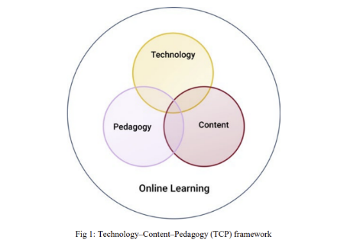
Figure 4. Technology-Content-Pedagogy (TCP) framework.
A cognitive lens completes the picture. ADHD is closely tied to weaknesses in executive functions such as working memory, inhibition and cognitive flexibility; any instructional medium that reduces those loads can improve performance. External goal cues (checklists, timers), rapid formative feedback, and “safe‑fail” retries do precisely that, giving learners space to focus on linguistic content rather than juggling multiple mental steps. At the same time, multimodal prompts - visual, auditory, kinesthetic - provide redundant pathways that help compensate for transient lapses in attention.
Taken together, these strands point toward a design blueprint for Attenglish. Short, learner‑controlled sessions nurture autonomy; points, badges and visible skill trees feed competence; optional peer leaderboards and co‑operative challenges satisfy the need for relatedness. Text‑to‑speech, audio recording and image supports ensure multiple means of representation, while micro‑writing tasks, voice responses and emoji reactions offer multiple means of expression. Finally, real‑time analytics identify when a learner’s attention flags, allowing the system to shorten activities or insert a movement break - an algorithmic nod to the executive‑function research. Grounded in SDT, UDL/TCP, presence theory and cognitive‑load research, such an ecosystem is positioned to convert fleeting engagement into sustained language growth for students who have historically found that difficult to achieve.

Managing ADHD Symptoms in Children through Technology‑Driven Serious Games
The most up‑to‑date synthesis of game‑based interventions for ADHD is the systematic review by Doulou and colleagues [7]. Adhering to PRISMA‑2020 procedures, the authors screened 784 records and retained thirty empirical studies that used serious digital games designed for therapeutic or educational outcomes - to support children with ADHD across five delivery platforms: PC, mobile/tablet, brain‑computer interface (BCI) or neurofeedback, virtual reality (VR) and augmented reality (AR).
Methodological profile:
Most trials enrolled clinically diagnosed children between six and thirteen years, implemented pre/post or randomized‑controlled designs, and reported both behavioral and neurocognitive outcomes. Interventions were deliberately brief yet intensive: four‑to‑six weeks in length, with three‑to‑five sessions per week, each session lasting 15–30 minutes - an arrangement that dovetails with school timetables and home routines.
Domains of change:
Outcomes clustered around executive‑function constructs - visuo‑spatial working memory, sustained and selective attention, inhibitory control, cognitive flexibility, and planning/organization - together with socio‑emotional competences such as emotion regulation and social communication. Medium‑to‑large improvements were consistently observed for working memory, attention and inhibition; smaller but significant gains appeared in planning, problem‑solving and emotion regulation. Across platforms, typical effect‑size ranges were:
- PC games: d ≈ 0.50–0.90 for working memory and inhibition.
- Mobile/tablet games: d ≈ 0.45–0.75 for sustained attention and motivation.
- BCI/neurofeedback games: d ≈ 0.60–1.10 for normalizing theta/beta ratios and executive alerting.
- VR experiences: d ≈ 0.40–0.70 for cognitive flexibility and emotion regulation.
- AR quests: d ≈ 0.35–0.60 for planning and real‑world skill transfer.
Design principles that matter:
Two recurring mechanics explain much of the observed efficacy. First, adaptive‑difficulty loops keep task demands just above each child’s current threshold, sustaining the dopamine‑mediated reward circuits that are typically under‑activated in ADHD. Second, rich multisensory feedback (visual, auditory, sometimes haptic) scaffolds self‑monitoring and metacognitive awareness - deficits that often hamper academic progress.
Limitations and gaps:
Despite promising short‑term gains, most studies tracked outcomes for less than three months, leaving durability in question. Language‑learning variables - verbal working memory, vocabulary growth, grammar - were rarely assessed, an important omission for interventions such as Attenglish. Few trials incorporated parent‑mediated data loops or reported socioeconomic diversity, constraining generalizability and home–school integration.
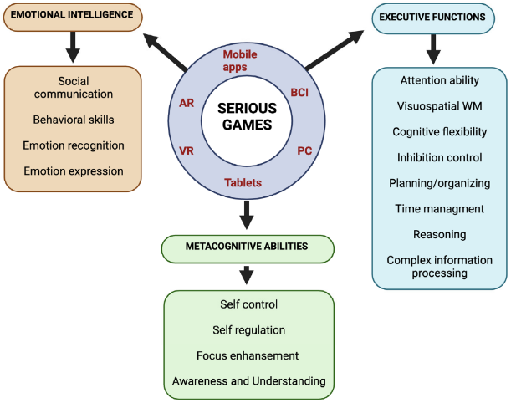
Figure 5. Serious games and areas of improvement through multiple technologies.

Executive-Function and Working-Memory Training Apps
Beyond motivation and multimodal design, language growth for ADHD learners is often gated by core executive‑function (EF) weaknesses - working‑memory limits, poor inhibition and fragile time‑management.
The best‑studied platform is CogMed Working Memory Training (CWMT). Delivered through a game‑like interface, CWMT adjusts span length in real time and rewards streaks of correct trials. In a randomized pilot with 7‑ to 11‑year‑olds diagnosed with ADHD, there were reports of significant gains on AWMA verbal and visuospatial span tests, although transfer to complex WM tasks was modest [8]. Crucially, the effect was strongest when a “coach” provided daily feedback - evidence that external scaffolds, not just adaptive difficulty, sustain effort over the 25‑session regimen.
More recent work shifts from pure span drills to embedded EF supports. Weisberg et al.’s TangiPlan uses RFID‑tagged tokens that children place around the house each night; the next morning visual timers light up as tasks are completed, off‑loading planning and temporal sequencing. Pilot data showed sharper on‑time arrival at school and fewer forgotten items - behaviors tightly linked to language‑learning persistence (e.g., bringing the right notebook, submitting homework recordings).
Gesture‑ and motion‑based systems add a kinesthetic channel. Garcia‑Zapirain et al. paired Leap Motion hand tracking with eye‑tracking in a “Math Flower” exercise: petals turn green only when the child holds gaze and performs the correct hand movement. The dual‑sensory load improved sustained attention and hand‑eye coordination, both predictors of phoneme‑grapheme mapping success. Likewise, Lim et al.’s BCI‑driven CogoLand used EEG attention metrics to slow an avatar when focus waned, producing post‑training improvements on Conners CPT that outperformed a control game.
Several design principles cut across these studies:
- Adaptive chunking - tasks begin well below capacity and expand only when success is stable, preventing early overload.
- Immediate, multisensory feedback - color changes, auditory pings and haptic cues externalize “meta‑awareness” of performance.
- Coach or parent dashboards - progress bars and daily‑goal alerts keep adults in the loop, a factor repeatedly linked to higher completion rates.
- Safe‑fail retries - errors trigger a short explanatory loop rather than a penalty, preserving motivation while rehearsing correct sequences.
Integrating such EF scaffolds into Attenglish means more than tacking on a memory mini‑game. Every vocabulary quest can start with a visual checklist, every grammar puzzle can display a running “steps left” meter, and timed challenges can auto‑extend for users whose working‑memory profile (captured during onboarding) falls below benchmark. By weaving EF supports into the core language tasks - rather than siloing them in a separate module - the app aligns with the evidence that executive control improves fastest when practice occurs in authentic, goal‑relevant contexts.
In short, the EF/working‑memory literature suggests that language apps for ADHD learners succeed when they behave like external frontal lobes: tracking progress, pacing information, and prompting reflection in real time. Attenglish’s design roadmap adopts those lessons, ensuring that cognitive scaffolds are as integral as phonics algorithms.

Parent‑Engagement & Home–School Data Loops
Parent engagement is often the weakest link in ADHD interventions; by the time paper charts or delayed e-mails reach home, the teachable moment has passed. Digital “data-loop” platforms shorten that delay by turning classroom telemetry into same-day insights for families [9].
- WHAAM lets teachers and parents co-log ABC (Antecedent-Behavior-Consequence) events and review cloud dashboards. In a semester-long trial (28 pupils, 60 % ADHD) daily sharing cut response-time from 4.8 days to < 24 h and halved off-task behavior—especially when dyads reviewed the dashboard twice weekly.
- SnappyApp gamifies a Continuous Performance Test: children tap Pokémon-style targets while public leaderboards spur competition; parents get micro-reports on focus streaks. After six weeks omission errors fell 18 %, and 83 % of caregivers reported a clearer picture of day-to-day attention swings.
- AWMA-S delivers ten-minute working-memory drills at home and e-mails percentile scores to teachers. Classrooms that used these scores to tweak seating and assignment chunking saw a 12-point jump in reading-fluency growth.
- Early prototypes now pair attention games with EEG headbands; avatars slow when focus dips, and weekly trend reports help parents time study sessions, showing larger gains than non-adaptive controls.

Four design principles recur:
- Bidirectional granularity – parents receive bite-size daily snapshots; teachers see multi-week trends.
- Sub-24 h latency – same-day data enables next-morning adjustments.
- Shared taxonomies – identical labels (“inhibition”, “lexical recall”) prevent interpretive drift.
- Positive-bias framing – progress bars highlight improvements, bolstering motivation for children and self-efficacy for parents.

English Studies in The Israeli Education System
The State Comptroller of Israel’s audit of English-language teaching in Israel offers a revealing chronicle of a reform that began with ambition and ended in quiet retreat [10]. English, the report reminds us, is not simply another school subject in Israel; it is the key to university admission, social mobility, and participation in a globalized workforce. Recognizing chronic weaknesses - especially in pupils’ spoken fluency, the small share of high-schoolers attempting advanced matriculation levels, and a scarcity of fully trained teachers - the Ministry of Education launched the National English Program in September 2017. For three years it moved with purpose: “Sulamot” classes added hours so promising learners could climb from 3 to 4 to 5 units of Bagrut, tiered oral-language initiatives such as “Let’s Talk” and virtual mentoring energized classrooms, and an annual target of 1 000 certified recruits aimed to stem staff shortages. External evaluators recorded enthusiastic debate sessions and early gains in the proportion of pupils entering higher-level exams.
Yet the scaffolding proved fragile. Budget trims, competing priorities and the fiscal shock of COVID-19 hollowed out the program long before its planned five-year horizon. By 2020 dedicated hours for “Sulamot” had been slashed 75 percent, library and mentoring schemes were frozen, and the ministry quietly stopped referring to the effort as a national initiative. Despite the headline rise - from 37 percent in 2017 to 48 percent in 2022 - in Year-12 students sitting 4- or 5-unit English, deep inequities persisted. Two-thirds of pupils in the wealthiest municipalities attempted the 5-unit paper, compared with barely a quarter in the poorest. Only 27 percent of Arab-sector students and 11 percent of Haredi students reached that level, while almost a quarter of Bedouin pupils took no English matriculation exam at all. University placement tests told a similar story of brittle achievement: a mere 30 percent of 5-unit graduates and 4 percent of 4-unit graduates earned exemption from remedial English, suggesting that examination grades often outstripped functional competence.
Teacher supply was the reform’s Achilles’ heel. Although recruitment targets were nominally met, attrition and demographic growth left 711 vacancies at the start of the 2022/23 year; one teacher in four lacked the specialist certification legally required. Professional coaching, touted as the bridge between policy and pedagogy, reached fewer than a third of schools, while others either did not request help or requested it in vain. Compounding these human-resource gaps was an absence of national formative assessment. After a single baseline survey in 2018, no systematic measurement tracked pupils’ progress or the cost-effectiveness of individual program strands, leaving decision-makers to prune budgets without evidence of what worked.
The Comptroller concludes that Israel now needs a fresh, adequately financed multi-year plan built on CEFR standards, one that hard-wires equity targets for Arab, Bedouin and Haredi learners, forecasts teacher demand district-by-district, and restores a robust evaluation spine through the national assessment authority. Without such guard-rails, the report warns, higher enrolment in advanced tracks may continue to mask fragile skills and widening social gaps, undermining English as the passport to higher education and the modern labor market that policy-makers originally envisioned.

Expected Achievements
In our project, we aim to develop a mobile application, designed specifically to support English language learning for pupils with ADHD/ADD in elementary through high school.
The core achievement of the project is the creation of an adaptive and engaging educational platform that caters to the unique learning styles and attention-related challenges faced by students with ADHD. The final product will be a fully functional, multi-OS mobile app that blends elements of gamification, multimedia learning, progress tracking, and attention-supportive design principles.
The application will include several key components:
- A structured learning path composed of short, focused lessons in vocabulary, grammar, and conversational English. These lessons will be delivered through interactive exercises, visual cues, and AI voiced narration to reduce cognitive overload.
- A gamified learning environment where users can earn points, badges, and level up through consistent practice, with real-time feedback to keep engagement high and distractions low.
- A customizable learning experience where the student or teacher can tailor the pace, difficulty, and types of exercises based on individual needs, ensuring better alignment with each student’s attention span and working memory capacity.
- A smart algorithm at the core of the app will track each user’s performance and attention behavior (e.g., task completion time, retries, skipped items) and use this data to personalize future exercises. For instance, if a student consistently struggles with past tense verbs, the system will increase exposure to such content using alternative teaching methods (e.g., animations, repetition, or contextual examples).
- A teacher dashboard, designed for the stakeholder, will allow educators to view class-wide and individual progress, assign specific modules, and provide reinforcement in weak areas.
The success of the project will be evaluated based on several criteria:
- Technical performance: The application must run smoothly on targeted mobile devices without crashes or delays, and the adaptive algorithm must properly log and respond to user data.
- Usability: Students with ADHD should be able to navigate the app intuitively, stay engaged with the content, and show a preference for using it compared to standard learning tools.
- Educational effectiveness: measurable gains in listening, speaking, reading, and writing will be shown through improved post-test (CEFR-aligned) scores versus baseline, quicker task completion with fewer retries, and sustained weekly app use of the users.
- Stakeholder satisfaction: Our main stakeholder, Keren Yerushalmi and other English teachers of grades 3rd to 12th, must find the dashboard informative and useful for lesson planning and student support.
By focusing on a learner-centered design grounded in both educational theory and ADHD-specific cognitive research, the project aspires to create not just an app, but a meaningful intervention in the English learning journey of neurodiverse students.

Engineering Process

The Process
The project began when we were searching for an engaging topic for our capstone project and decided to create a technological product that combines software development with effective learning tools for students who have attention-deficit difficulties. During a conversation with our advisor, she introduced us to Karen, our client and an English teacher in a middle school, who had already launched a special English-learning program for struggling students. The meeting of our engineering ambition and her classroom need ignited the idea that would become Attenglish.
The process started with a thorough initial research and analysis phase. We conducted broad market research to examine existing language-learning apps, school CMS platforms, and any tools tailored for learners with ADHD. Our objective was to map the current landscape, spot functional gaps - such as the absence of short, three-minute micro-lessons and built-in attention cues - and understand user preferences. Complementing this study, we performed an extensive literature review of peer-reviewed articles on digital learning for students with attention challenges, extracting design heuristics on cognitive-load management, reward pacing, and inclusive accessibility standards. Finally, we carried out follow-up interviews with Karen and two additional English teachers and two different parents to collect requirements, uncover pain points in current solutions, and validate our initial concept.
We then moved into the requirement-gathering and specification phase. Detailed user stories and usage scenarios captured both functional and non-functional requirements of the proposed system, ensuring a precise understanding of user needs and expectations. On the technical side, we defined our expected achievements and the core technology stack.
Design & Prototyping Phase
- UI design with Figma – Wireframes and interactive mock-ups for the teacher content-management portal and the student app emphasize a calm, low-stimulus interface. Presenting these artefacts to Karen will let us gather targeted feedback early and refine color palettes, navigation flow, and badge animations so they align with ADHD-design best practices.
- Front-end with Flutter – A single Flutter codebase will deliver native-quality experiences on Android tablets, Chromebooks, and the web, guaranteeing smooth animations while keeping maintenance overhead low.
- Back-end foundations – Flutter will also power lightweight server functions, while Firebase Authentication secures log-ins for minors and Cloud Firestore provides real-time, serverless data storage that scales automatically with classroom adoption.
Constraints Affecting the Development Process
User Constraints
Our users include K–12 students with ADHD, their teachers, and the students’ parents, all of whom vary in technical proficiency and device familiarity. Students require a calm, low-stimulus interface with bite-sized activities (no more than three minutes) and clear, consistent navigation. In addition, the app must actively engage them through gamification - using points, badges, mini-challenges, and progress tracking - and provide tiered learning levels tailored to different age groups and proficiency stages. Teachers need a simple, web-based content-management portal that lets them upload lessons without frequent app-store updates. Parents should also be able to log into the app to monitor their children’s progress, review performance metrics, and support learning at home. To address these constraints, we will conduct iterative user-testing sessions and feedback workshops with pupils, instructors, and parents throughout the development process.
Technical Constraints
Our choice of technology stack, development tools, and target platforms introduces several challenges. Guaranteeing seamless operation across a range of devices and operating systems - particularly iOS and Android - demands extensive compatibility testing and fine-tuning. Incorporating advanced capabilities like AI brings additional hurdles in terms of computational performance, model accuracy, and overall reliability. At the same time, the inherent limitations of mobile hardware - restricted CPU power, memory capacity, and battery life - place further boundaries on our design. To manage these constraints, we’ve adopted a modular architecture that enables us to build, test, and optimize each component independently.
Time Constraints
Our development window spans only a few months, making timely delivery of every milestone essential. To prevent any phase from slipping, we’ve crafted a granular project timeline with specific checkpoints and deliverables. Tasks are allocated according to each team member’s expertise, allowing parallel progress on different components while maintaining tight coordination. Regular sync-ups and a modular task breakdown help us secure small, verifiable wins that build momentum, keeping the project on track.
Integrated Constraint Management
We address all our constraints through a coordinated strategy. Technical challenges are met with a modular architecture that lets us optimize individual components and ensure cross-platform compatibility. Time pressures are handled via agile practices - bi-weekly sprints, daily stand-ups, and continuous integration pipelines - that allow rapid adaptation and steady delivery. Regulatory and privacy requirements are baked-in through privacy-by-design measures, including data minimization, encryption, and routine security audits. User needs will be continuously refined through iterative testing and feedback sessions, guaranteeing an intuitive, accessible experience. This multifaceted approach keeps us aligned with our goals while effectively navigating each development hurdle.
This structured path - from discovery through specification, prototyping, and iterative validation - ensures that Attenglish addresses real educational pain points while meeting tight budgetary, legal, and timeline constraints. By keeping each phase evidence-driven and stakeholder-centered, we position the platform to deliver measurable improvements in English acquisition for students with attention difficulties.

The Product
The app wraps every core language skill - reading, listening, speaking, and writing—inside bite-size, game-like interactions that last no more than three minutes. Immediate audio-visual feedback, movement-break prompts, and an adaptive difficulty loop keep attention anchored while reducing cognitive overload. Beyond the pupil experience, a companion web portal empowers teachers to create or remix multimedia lessons in minutes and to track each learner’s progress on a live dashboard. Parents receive concise, positive-framed snapshots that close the home–school feedback loop.
Under the hood, Attenglish relies on a lightweight client crafted with Flutter and a single serverless backend powered by Firebase. Authentication, real-time data synchronization, and push notifications are handled out-of-the-box, allowing the team to focus on pedagogy rather than DevOps. A rules-based engine personalizes the journey: it surfaces remedial micro-tasks when a learner struggles, celebrates streaks with badges, and recommends review sessions just before forgetting would normally occur. All logic runs in secure cloud functions, so feature updates reach every device instantly without app-store delays.
The result is a cohesive ecosystem that feels playful to students, insightful to teachers, and effortless to maintain. By weaving together cognitive-science principles (spaced repetition, multisensory cues), evidence-based ADHD accommodations (short sessions, minimal UI clutter), and cloud-native engineering, Attenglish positions itself as a scalable intervention capable of elevating English proficiency across diverse Israeli classrooms.
Algorithms
  - Pupil Registration & On-Boarding
When a new user signs up with their Ministry-issued ID, a Registration Cloud Function validates the token against Firebase Authentication, creates a (/users/{uid}) document, and seeds it with defaults: role, school, grade, language interface (Hebrew ↔ English), and an empty competency profile. The same function enrolls the pupil in their class roster (/classes/{classId}/students/{uid}) and schedules the initial placement quiz.
  - Task Assignment & Spaced Repetition
Every lesson template contains metadata: skill focus, difficulty band, and an SM-2 spaced-repetition schedule. A nightly Task Scheduler Function filters lessons whose target level ≤ pupil level and whose next-review timestamp ≤ now. It then assembles a Daily Mission Pack of 6-8 varied micro-tasks, ensuring a balance of new material (70%) and scheduled reviews (30%). Completion scores feed back into the SM-2 algorithm to reschedule the next exposure—shorter intervals after errors, longer after high accuracy.
  - Engagement & Intervention Triggers
A Progress-Watcher Function streams write events from (/progress/{uid}/{lessonId}). Rules trigger when three low-score events occur within 48 hours or when a pupil streaks five high-score events. Low-score streaks flag the teacher dashboard and queue remedial tasks; high-score streaks unlock badges and optional “mainstream re-entry” recommendations, visible only to teachers.
  - Database
Attenglish deliberately consolidates all persistent data into a single Cloud Firestore database to minimize operational overhead and to guarantee atomic, cross-collection security rules.
Collection | Purpose | Typical Document Fields
/users | Authentication profile & role metadata | displayName, role, schoolId, level, avatarUrl
/classes | Class roster & teacher link | name, teacherId, grade, schoolId
/lessons | Master lesson templates | title, difficultyBand, mediaRefs[], taskList[], sm2Params
/progress/{uid} | Per-pupil task results & timestamps | accuracy, attempts, nextReviewAt, timeOnTask
/badges/{uid} | Gamification state | badgeId, earnedAt
/events/{day} | Audit & analytics log (append-only) | eventType, uid, timestamp, payload

Binary assets - images, audio, and short video clips - live in Firebase Storage; their gs:// paths are referenced from lesson documents. This layout keeps reads ≤ 10 document fetches per screen while enabling server-side exports to BigQuery for longitudinal analytics. Because everything sits in one Firestore instance, daily backups and security-rule updates occur once, not per-tenant, aligning with the project’s “single-database” goal while leaving room for future multi-region instances if data-residency laws require it.

Functional Requirements
  - Ubiquitous Requirements (System always behaves this way):
- The system shall present English learning materials as multimodal content (text, audio, images, touch-based games) to support varied learning styles.
- The system shall provide a two-lesson cycle per topic: one to introduce content and one to reinforce it.
- Learners can revisit the intro lesson any time after completion.
- Every topic contains a Practice Lesson that uses spaced repetition.
- When the teacher publishes a Lesson, she must set the spaced‑repetition schedule for it's Practice Lesson.
- A pupil may adjust the Practice Lessons intervals only if the teacher explicitly toggled “Allow pupil to customize spaced repetition intervals” while uploading the lesson.
- The system shall allow teachers to create and upload custom exercises (e.g., drag-and-drop, sentence construction, dictation).
- The system shall support gamified vocabulary and sentence-building activities.
- The system shall allow teachers to input and track assessments (e.g., reading fluency, dictation, short quizzes) using customizable scales.
- The system shall support multisensory learning activities, including sound segmentation, image association, and touch-based manipulation (e.g., virtual letter tiles).
- The system shall support interaction with digital flashcards and matching games (Wordwall-style).
- The system shall support AI-generated exercises (e.g., unseen passages, tailored sentence tasks).
- The system shall allow teachers to share content instantly (e.g., snap and send whiteboard photo).
- The system shall provide simple dashboards to show individual learning paths and progress.
- The system shall store and present prior lessons, stories, and activities in a virtual classroom format.
  - Event-Driven Requirements (In response to something happening):
- When a student achieves a milestone, the system shall send a push notification to their parents.
- When a student consistently performs at a higher level, the system shall suggest reintroduction to mainstream English class.
- When a teacher creates an assessment, the system shall allow configuration of timing, difficulty, and input method.
- When a Practice Lesson is available or due – the shall send a push notification to the user.
- When a student uses the app, the system shall adapt activity difficulty based on their profile and usage history.
  - State-Driven Requirements (When the system is in a given state):
- When the user is offline, the system shall allow access to cached lessons and exercises.
- When the app is used on restricted school tablets, the system shall function fully without requiring unrestricted internet.
  - Optional Feature Requirements:
- The system may restrict students to English letters during writing tasks to discourage use of tools like Google Translate.
- The system may include a visual timer for reading or timed activities.
- The system may include an alert mechanism to notify teachers when a student is struggling (e.g., red buzzer).
  - Unwanted Behavior Requirements:
- The system shall prevent distraction-heavy game designs - games must be minimalistic and focused.
- The system shall prevent the use of unauthorized third-party logins (e.g., Google).

Non-Functional Requirements
  - Usability:
- The app shall offer a simple, clear UI with visual cues and minimal distractions.
- The app shall support both Hebrew and English interfaces, with ability to toggle and reward use of English interface.
- The app shall include tutorials and visual guides for teachers and students.
  - Accessibility:
- The system shall support accessibility features, including adjustable font sizes, dyslexia-friendly fonts, and color schemes.
- The system shall allow teachers to create adapted content (e.g., for non-readers, slow readers, and fluent readers).
  - Performance:
- The system shall load content within 2 seconds on school-provided tablets and operate smoothly without lag.
  - Portability:
- The app shall run on tablets, laptops, and mobile phones, with optimization for school tablets being mandatory.

  - Security:
- The app shall comply with Ministry of Education data privacy rules.
- The system shall use ministry-issued codes for login and prohibit third-party sign-ins like Google.
  - Data Retention:
- The system shall retain student progress data over multiple academic years to support long-term tracking.
  - Interoperability:
- The app shall be integrated with Ministry systems (Mahov) for grade reporting and record keeping.
- The app shall export student records in PDF, Word, and Excel formats.

To meet the outlined non-functional requirements, we will adopt a user-centered and modular development approach, ensuring that each requirement is systematically addressed during the design, development, and testing phases. Usability and accessibility will be prioritized using intuitive UI frameworks, clear visual hierarchies, and features like dyslexia-friendly fonts and customizable interfaces. The app will support both Hebrew and English languages, with interface toggling and rewards for using English to encourage immersion and learning. Onboarding tutorials and in-app guides will be integrated to support both teachers and students.
From a technical standpoint, performance optimization will be achieved using lightweight frontend technologies and efficient backend APIs to ensure sub-2-second content loading, especially on school-issued tablets. Cross-platform compatibility will be ensured using responsive design principles and thorough device testing. For security and data retention, we will implement secure Ministry of Education login APIs, ensure encryption of personal data, and store student progress in a centralized, long-term database. Finally, interoperability will be managed through API integrations with Mahov and export functionalities in common formats (PDF, Word, Excel), enabling smooth adoption in school workflows and compliance with institutional standards.

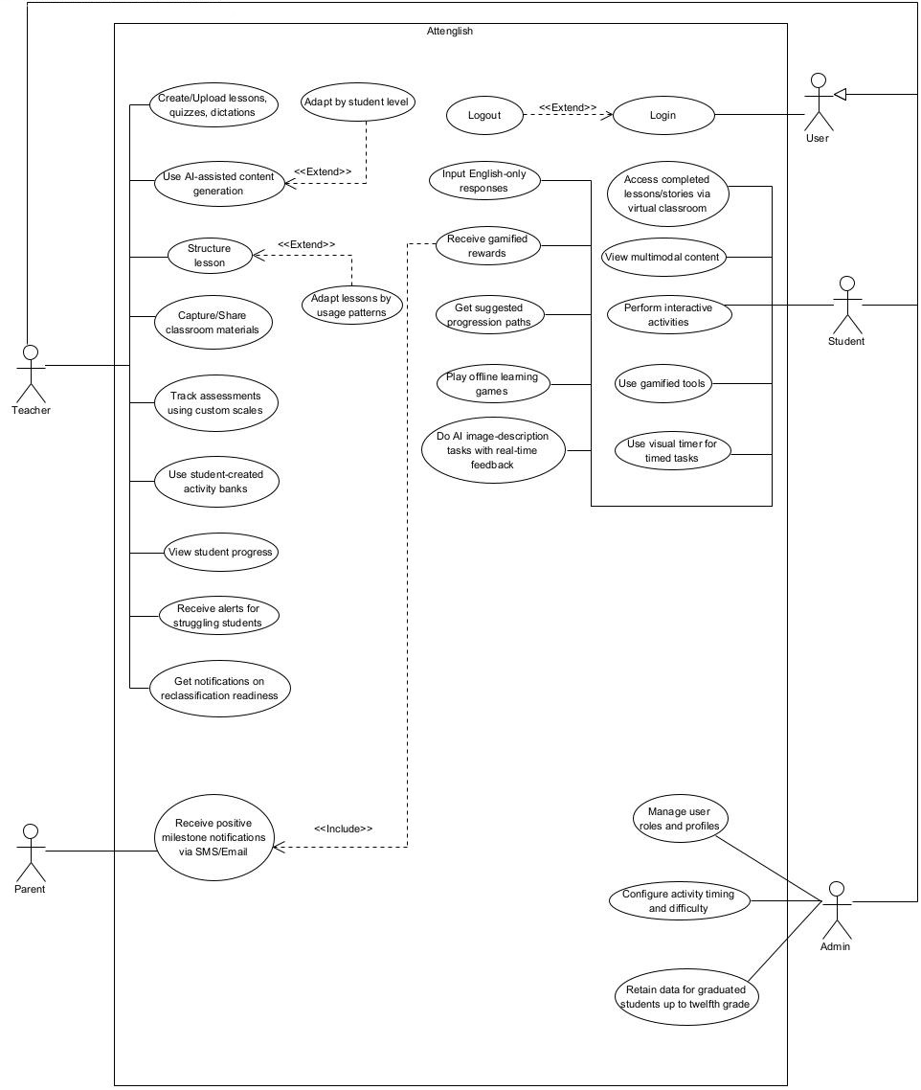
Use-Case Diagram

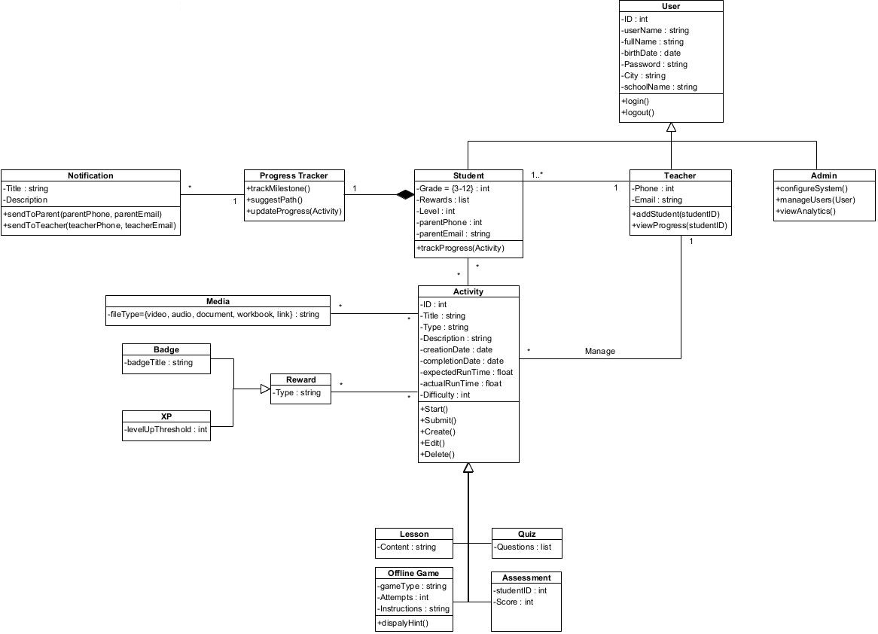
Class Diagram

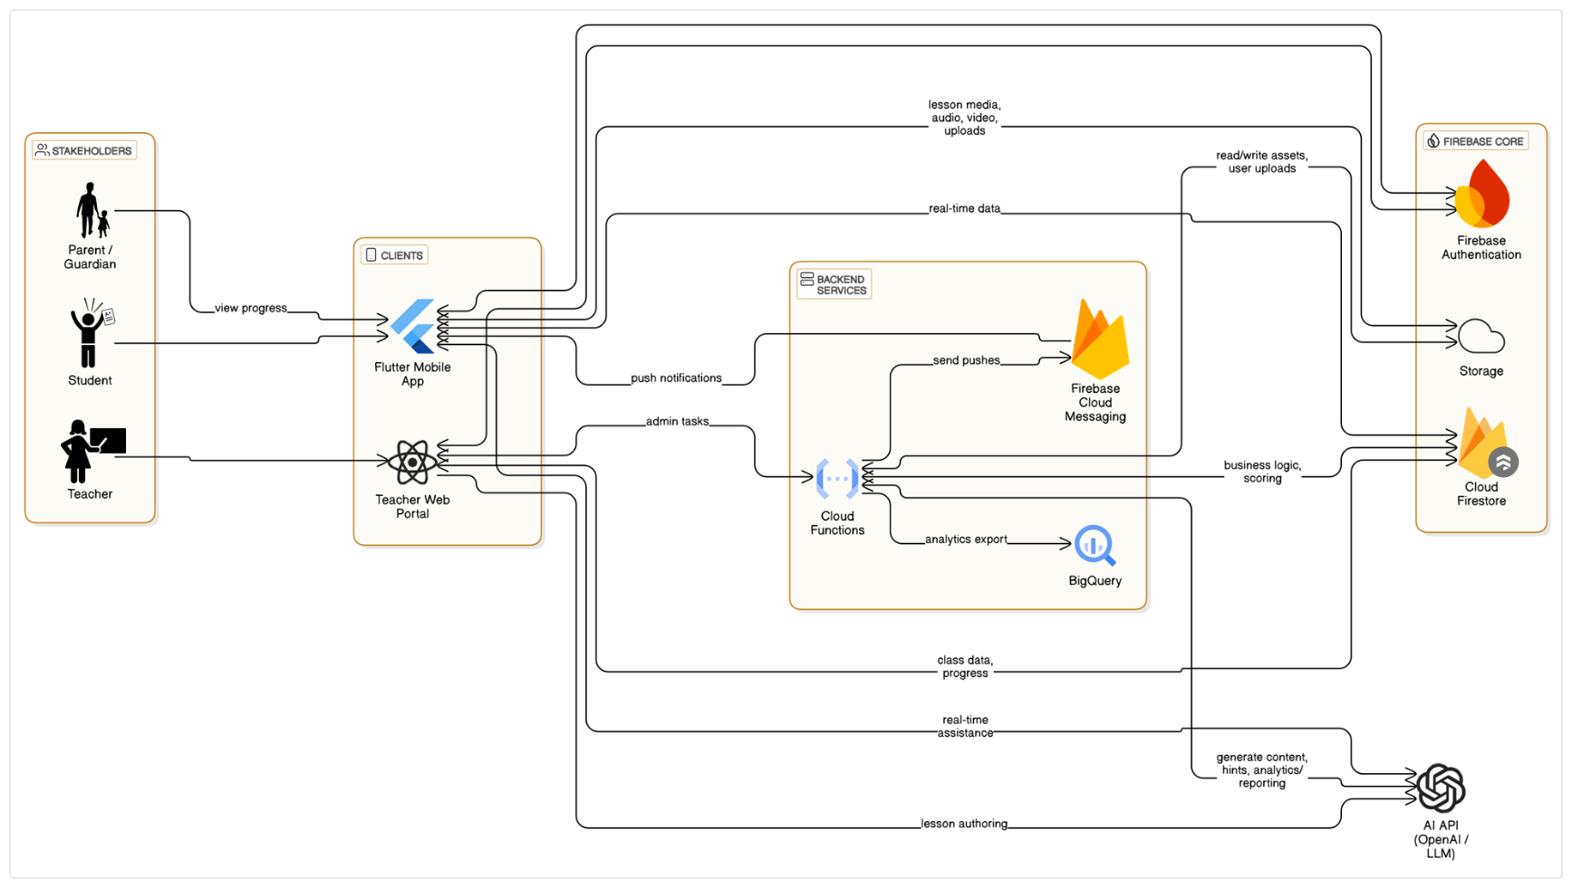
System Architecture

Front-End UI Concept
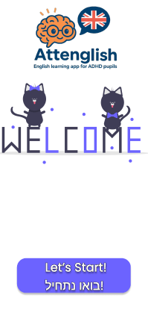
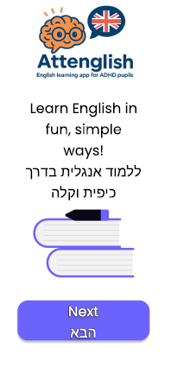
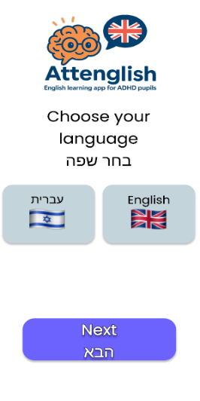

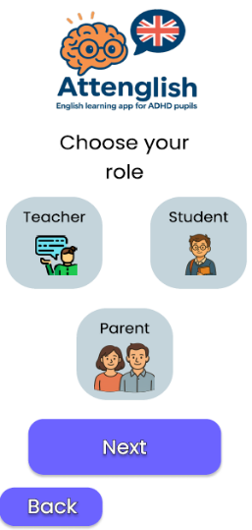
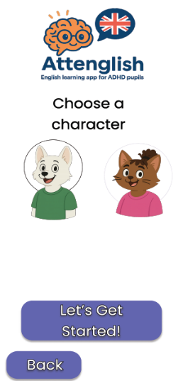
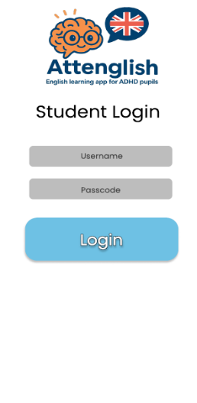

Quality Assurance and Testing Plan
Actor | Core Use-Cases to Validate | Desirable Test Outcomes | Primary Test Layer(s)
Student | • Login / Logout  • Access completed lessons/stories (virtual classroom)  • View multimodal content  • Perform interactive activities  • Use visual timer for timed tasks  • Input English-only responses  • Play offline learning games  • Do AI image-description tasks with real-time feedback  • Use gamified tools & receive rewards  • Get suggested progression paths | 1. Path flow: Login → open classroom → start timed activity → complete with English-only input → receive reward → suggested next task appears.  2. Offline mode: start a cached “learning game”, finish, reconnect, verify progress sync.  3. AI vision: upload image, receive description hints in < 1 s; profanity filter blocks inappropriate content. | Flutter widget tests → Firebase Emulator E2E → Manual functional & UX
Teacher | • Login / Logout  • Create / upload lessons, quizzes, dictations  • Structure lesson (and extend “Adapt by student level / usage patterns”)  • Capture / share classroom materials  • Track assessments on custom scales  • Use student-created activity banks  • View student progress dashboards  • Receive alerts for struggling students  • Get notifications on reclassification readiness | 1. Authoring: drag-drop PDF → AI content generator suggests 10 quiz items → teacher edits, saves lesson; lesson visible to assigned class.  2. Adaptive tweak: flag student as “needs shorter timer”; verify lesson copy auto-inherits new timer.  3. Alerting: student fails 3 consecutive tasks → Cloud Function sends teacher push & portal badge. | React component tests → Cypress E2E → Manual functional
Parent / Guardian | • Receive positive milestone notifications via SMS / Email | 1. Pupil achieves 5-day streak → Twilio SMS sent; verify correct phone masked in logs. | Cloud-Functions unit tests → Postman mock-callback
Admin | • Manage user roles & profiles  • Configure activity timing & difficulty  • Retain data for graduated students up to 12th grade | 1. Bulk CSV import → 100 users created with correct roles.  2. Change default timer from 45 → 30 s; confirm new lesson picks.  3. Archive graduated class; verify records are still queryable (read-only) after 30 days. | Jest unit → Admin-portal Cypress → Data-retention integration tests

Non-Functional Suites (cross-actor)
Category | Target & Metric | Tooling
Performance | ≤ 2 s P95 screen-to-screen load on Redmi 9A at 5× peak (≈200 concurrent pupils). | Firebase Test-Lab, k6
Accessibility | All student & teacher flows comply with WCAG 2.1 AA; color-blind safe palette. | Flutter-a11y audit, Axe-core
Security & Privacy | No unauthenticated read/write paths; OWASP Mobile Top-10 0 critical. | Firebase Rules fuzzing, MobSF, ZAP
Compatibility | Android 10+, iOS 15+, Chrome last 2; offline caching works. | Device farm matrix

References

[1] | G. Andreou and A. Argatzopoulou, "A systematic review on the use of technology to enhance the academic achievements of children with attention deficit hyperactivity disorder in language learning," Research in Developmental Disabilities, vol. 145, pp. 1-9, 2024.
[2] | D. V. Katsarou, E. Efthymiou, G. A. Kougioumtzis, M. Sofologi and M. Theodoratou, "Identifying Language Development in Children with ADHD: Differential Challenges, Interventions, and Collaborative Strategies," Children, pp. 1-9, 2024.
[3] | A. M. Mohamed, T. S. Shaaban and H. A. Jmaiel, "EFL Special Education Teachers’ Perspectives: Evaluating Game-Based Learning for ADHD Behavioral Disorders," Journal of Attention Disorders, vol. 28, no. 11, pp. 1482 - 1495, 2024.
[4] | R. Hite, G. Childers, G. Jones, E. Corin and M. Pereyra, "Describing the Experiences of Students with ADHD Learning Science Content with Emerging Technologies," Journal of Science Education, pp. 1-34, 2021.
[5] | E. Sciberras, M. Mulraney, V. Anderson, R. M. Rapee, J. M. Nicholson, D. Efron, L. Katherine, Z. Markopoulos and H. Hiscock, "Managing Anxiety in Children With ADHD Using Cognitive-Behavioral Therapy: A Pilot Randomized Controlled Trial," Journal of Attention Disorders, vol. 22, no. 5, pp. 515-520, 2018.
[6] | V. Gkora, "Advancing ADHD education: autonomy, technology, and inclusive strategies," GSC Advanced Research and Reviews, pp. 1-12, 2024.
[7] | A. Doulou, A. Drigas and C. Skianis, "Intercultural Education and ADHD: Τhe Use of Virtual Reality as a Means of Intervention and Assessment," International Journal of Online and Biomedical Engineering (iJOE), 2023.
[8] | A. Chacko, A. C. Bedard, D. J. Marks, N. Feirsen, J. Z. Uderman, A. Chimiklis, E. Rajwan, M. Cornwell, L. Anderson, A. Zwilling and M. Ramon, "A randomized clinical trial of Cogmed Working Memory Training in school-age children with ADHD: a replication in a diverse sample using a control condition," The Journal of Child Psychology and Psychiatry, vol. 55, no. 3, pp. 247-255, 2014.
[9] | A. Alexopoulou and A. Batsou, "Digital technologies for students with ADHD," International Journal of Science and Research Archive, vol. 9, no. 2, pp. 537-547, 2023.
[10] | The State Comptroller of Israel, "Learning English in The Israeli Education System," 2024.

Appendix

Interview With Keren Yerushalmi
How many students do you teach, and how many of them have attention or concentration difficulties?
Keren: I work with very small classes - around 8–10 students per grade (7th through 9th) - and a large portion of them are diagnosed with attention or concentration issues.

1. Workflow & Tools
How do you currently plan and organize your English lessons from start to finish?
Keren: In seventh grade - the most challenging level - I begin by mapping each student’s baseline, including identifying non-readers who don’t yet recognize letters. From there, my yearly program follows a single textbook that takes them from Hebrew to English in a very systematic progression: letter recognition, letter-sound combinations, word-level reading, then sentence construction, all aimed at preparing them for the Bagrut (matriculation) exams.
Which tools (apps, platforms, paper systems) do you rely on to create and store your lesson materials?
Keren: I use a blend of physical and digital: wooden letter-tile cubes for tactile word building; Wordwall digital flashcards and games for interactive drills; and ultimately everything is hosted in the Ministry of Education’s Educational Cloud. That cloud service lets me create folders and virtual classrooms, share links and AI-generated worksheets, and replace the old physical-folder system.
How do you share or distribute lesson content to students - via an app, email, paper prints, or another method?
Keren: All content lives in our Educational Cloud virtual classroom. Students simply log in to access worksheets, flashcards, and links I prepare, so I rarely print on paper anymore.
What steps do you take to adapt materials for different student needs, and what makes that process easier or more difficult?
Keren: I customize every text by enlarging fonts, switching to dyslexia-friendly typefaces, breaking paragraphs into chunks, and using high-contrast visuals. I leverage AI to auto-generate versions for non-readers, slow readers, and fluent readers - but I still need to manually review and model each version, which is time-consuming.
How do you track whether each student has received or completed their lessons?
Keren: I run monthly, in-class assessments - dictations, oral readings, timed reading with a visual timer, and short fill-in-the-blank quizzes. I record results on my phone via the school’s information system and also keep a personal one-to-six scale for reading improvement.
Which features from your current tools would you like to see included in the new app to ease lesson delivery?
Keren: I’d love built-in links to Wordwall’s interactive flashcards, an AI assistant that cleans up text and builds word banks, automatic insertion of “Karel Breaks” (my five-minute movement breaks), and a two-lesson reinforcement cycle that schedules both introduction and review lessons seamlessly.

2. Lesson-Planning & Assessment Challenges
What are the main "pain points" you encounter when designing assessments or exercises in reading, writing, listening, and speaking?
Keren: Adapting each test to multiple reading levels and formats eats up huge amounts of time. Moreover, homework completion rates are very low, so I prefer to keep assessments in class where I can engage students directly.
In what ways do attention difficulties (e.g., lack of focus, impulsiveness) affect your ability to assess true student understanding?
Keren: Students with attention challenges require micro-lessons and movement breaks. In a 45-minute class, I weave in two five-minute breaks - after a brief teaching segment and again before review - so I can reliably gauge their skills in real time without overload.
How do you identify which students are struggling with specific grammar points or vocabulary?
Keren: It begins with a seventh-grade placement test - below certain cutoff scores they get referred to me. Then I observe handwriting changes, monitor breathing patterns during oral reading for dyslexia indicators, and conduct formal mid-year and end-of-year reviews.
What challenges do you face when giving personalized feedback, especially in larger settings?
Keren: Luckily my classes are small enough (8–10) that I can rotate through personalized attention. For instance, I create a special workbook for a student with dyslexia and a targeted guide for someone with memory-retrieval issues, and I maintain a “reuse corner” of physical and digital games for extra practice.

3. Desired Features & Functionality
How would you like to create new lesson content - what multimedia elements (text, audio, images, video) would you include?
Keren: I envision integrated multimedia: text-to-speech for passages, image-based writing prompts where students scan barcodes to reveal pictures, audio dictation games where submarines match Hebrew and English words, and drag-and-drop video prompts.
What real-time progress metrics or alerts would help you intervene quickly when a student struggles?
Keren: An online “red buzzer” alert if a student is stuck, flags for low engagement, and a dashboard that signals when a student is ready to rejoin the mainstream class would be invaluable.
Which collaboration features (shared notes, co-editing, teacher-parent messaging) would improve your workflow?
Keren: While shared notes and co-editing sounded promising, I find push notifications to parents - celebrating when their child earns a trophy or hits a milestone - spark the most positive home engagement.
Which alerts (e.g., assessment reminders, low-engagement flags) would be most useful to you?
Keren: Automated reminders to evaluate assignments, low-engagement flags in a student’s profile, and real-time struggle alerts during lessons would streamline my workflow.

4. Accessibility & Usability
Which usability factors (simplicity of navigation, minimal distractions) are most important for your students?
Keren: A clean interface with straightforward navigation and micro-lessons - bite-sized activities - are essential. Visual timers, minimal on-screen distractions, and the ability to adjust session lengths help maintain focus.
How important is dividing lessons into micro-lessons or adapting to personal pacing?
Keren: Very important. My two-lesson cycle (introduction then reinforcement a few days later) and the ability to shorten modules for faster learners hit visual, kinesthetic, auditory, and memory channels in turn.
Which accessibility options (text-to-speech, high-contrast modes, alternative input methods) do you see as essential?
Keren: Text-to-speech, dyslexia-friendly fonts and color schemes, high-contrast visuals, touch-based drag-and-drop, and clearly structured movement breaks are must-haves.
Can you share examples of accommodations you currently provide (extended time, movement breaks) that you’d like in the app?
Keren: I schedule two five-minute movement breaks per lesson, use flexible seating (floor cushions, a basketball hoop), and allow extended time on tasks to manage attention spans.

5. Integration & Technical Requirements
Which existing systems (e.g., learning management, gradebook) should the app integrate with, and how?
Keren: Seamless integration with the Ministry’s EK grade-entry system and with Tara for automated report submission would streamline grading and reporting.
How would you prefer to manage user accounts and classes - SSO, uploading lists, or manual entry?
Keren: We currently use ministry-provided codes based on student IDs. I’d stick with that approach, since alternatives like Google login are restricted, and birthdates can lead to duplicate-ID issues.
Which export formats (CSV for grade tables, PDF reports) are required for institutional reporting?
Keren: Standard PDF, Word, and basic Excel exports cover our reporting needs.
How important is offline access - lessons available without internet and syncing when reconnected?
Keren: Critical. The app must function fully on school-issued tablets without connectivity and then sync automatically once online.
Can you describe the technical support, or training needs you foresee for teachers and students adopting the platform?
Keren: Clear step-by-step tutorials, visual cues, and dedicated support channels for both teachers and students will be essential for adoption.

6. Privacy, Security & Data Management
What privacy, consent, and data-ownership requirements does your school or district mandate?
Keren: Full compliance with Ministry of Education privacy regulations is non-negotiable. Users must explicitly accept consent agreements, and data-ownership policies need to be transparent.
Are there data retention or deletion policies (e.g., after graduation) that must be enforced?
Keren: I prefer retaining students’ progress history long-term as a motivational record; deletion should be configurable, but preserving that data adds value.
How should sensitive data (activity logs, assessment results) be secured in transit and at rest?
Keren: It must follow standard encryption protocols in transit and at rest, in line with Ministry guidelines.

Surveys Results
Questionnaire for English teachers (distributed by a relative, who is also a middle-school English teacher):
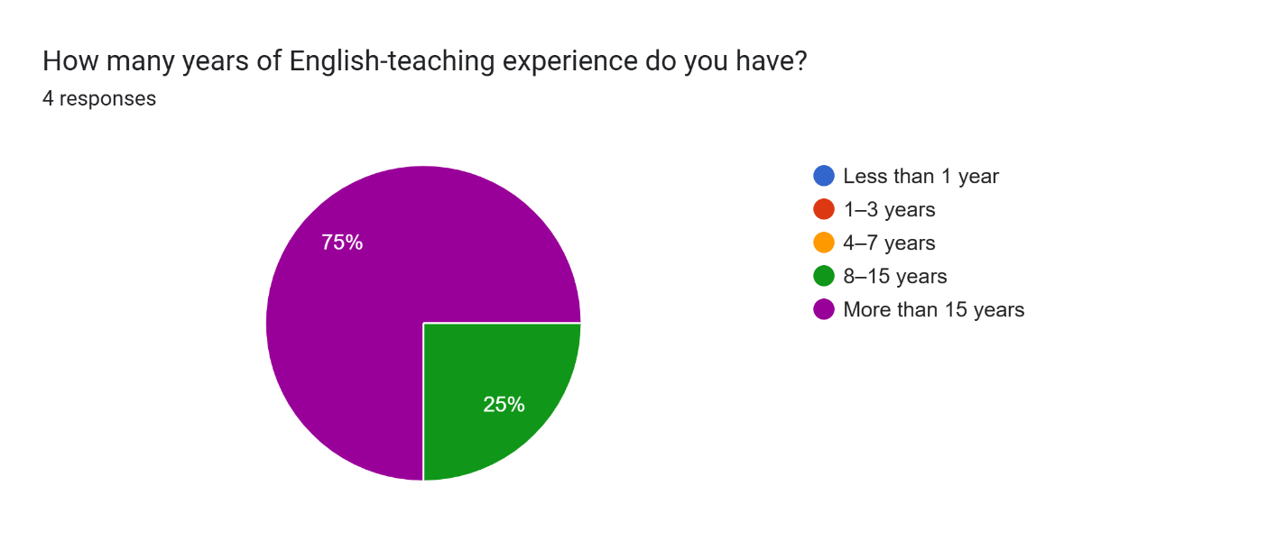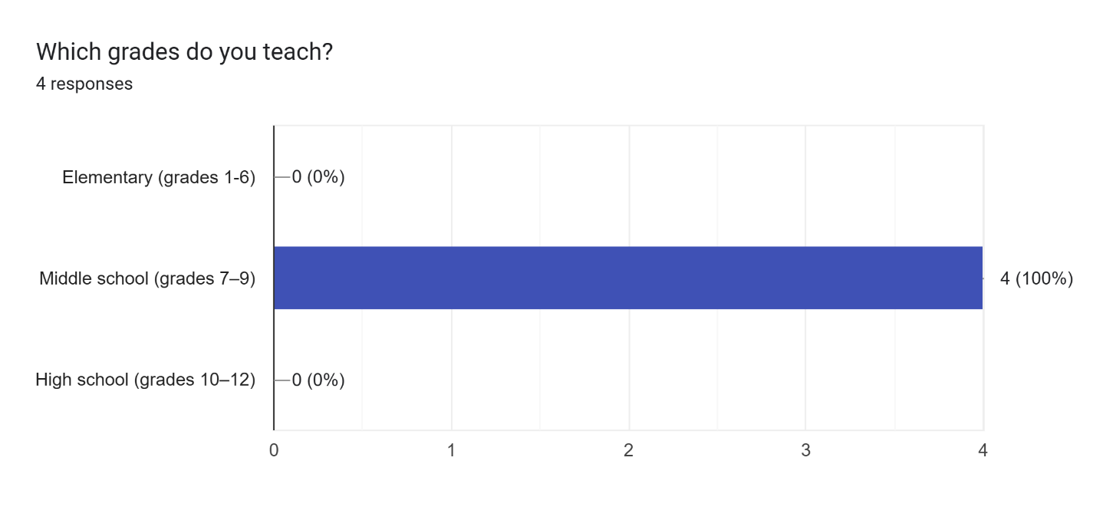

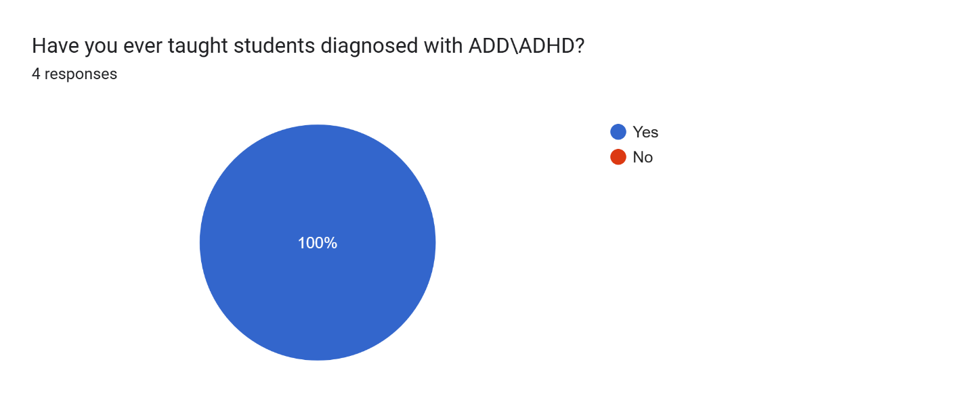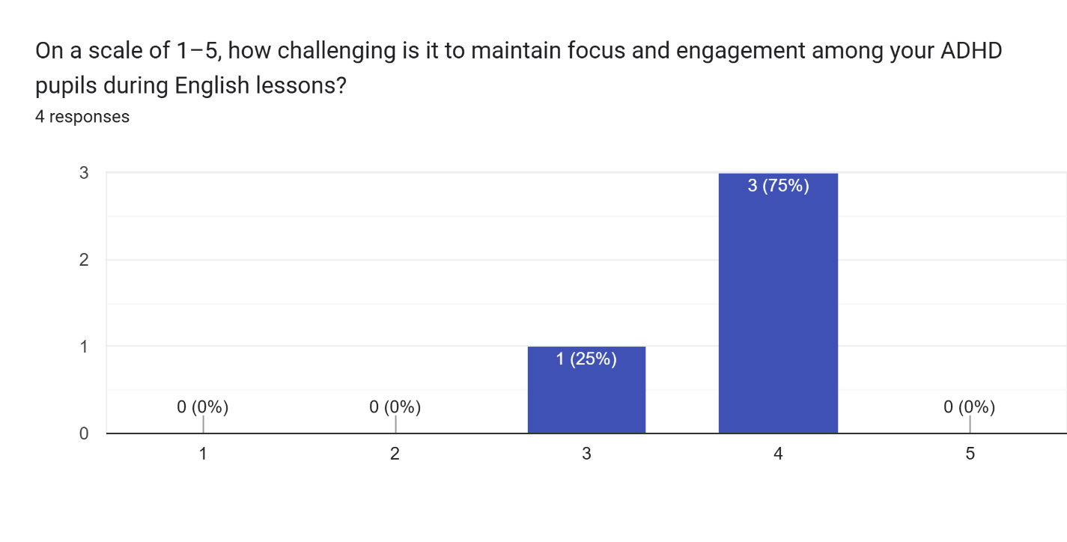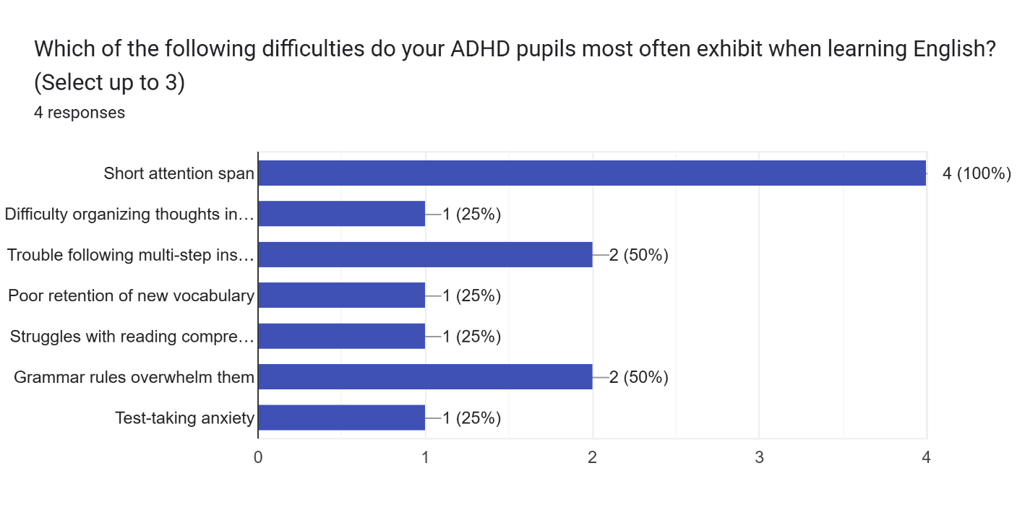

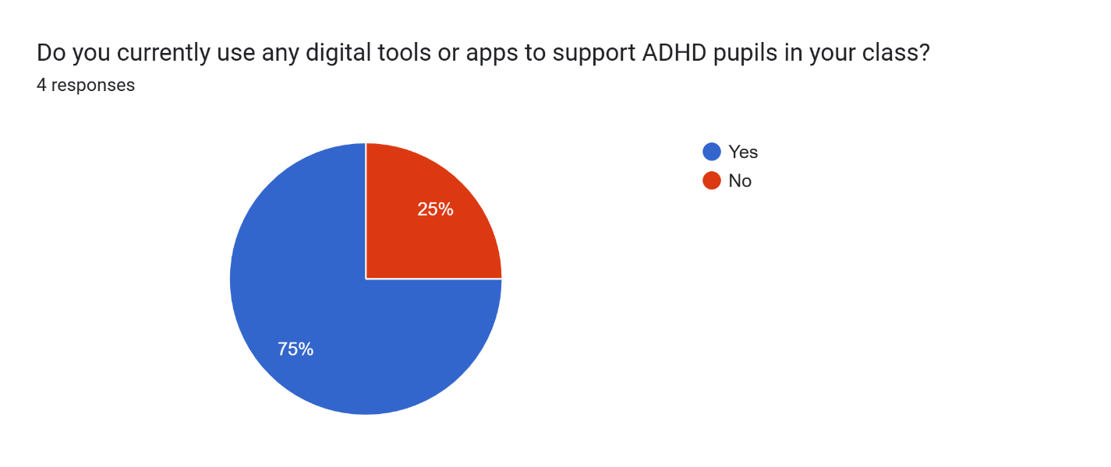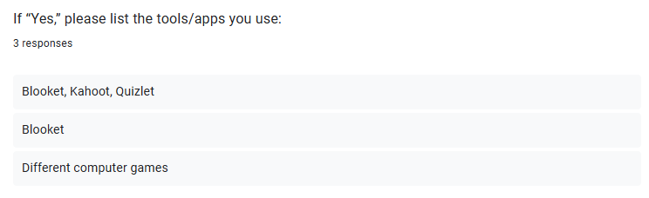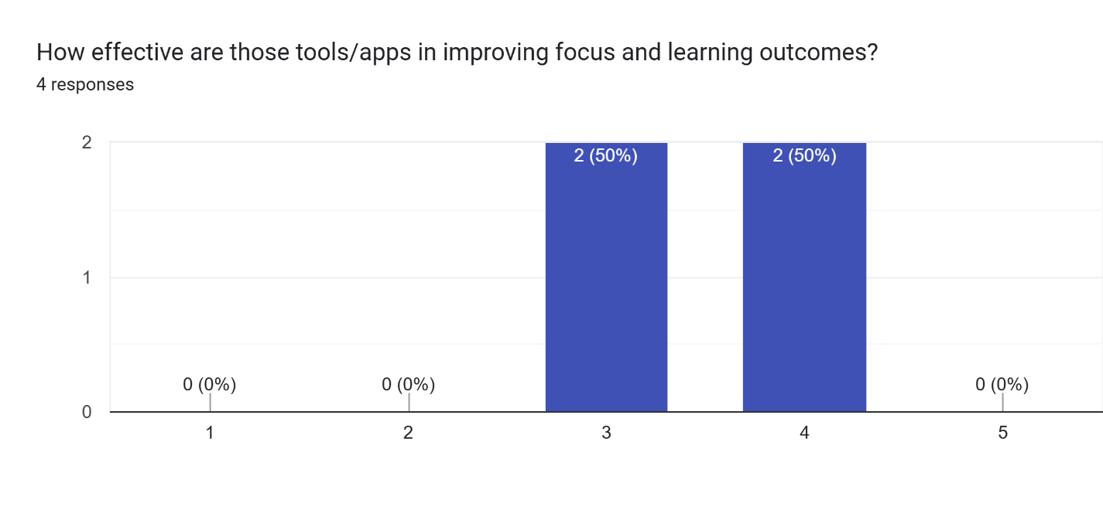

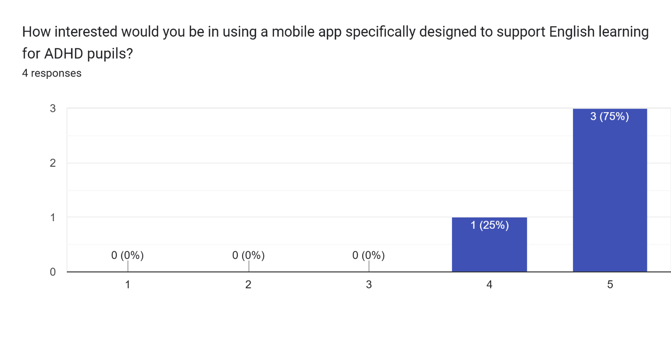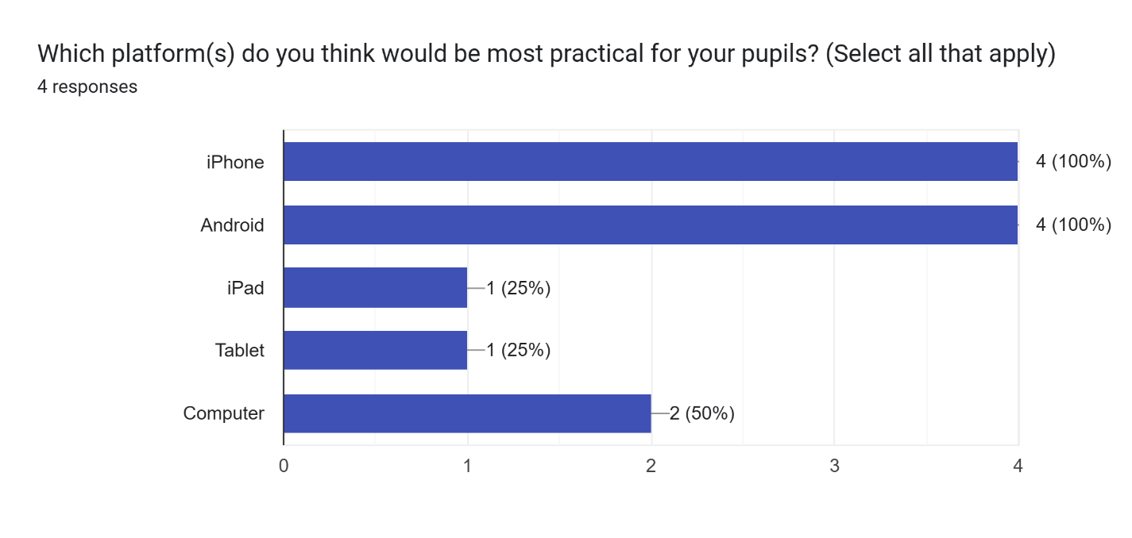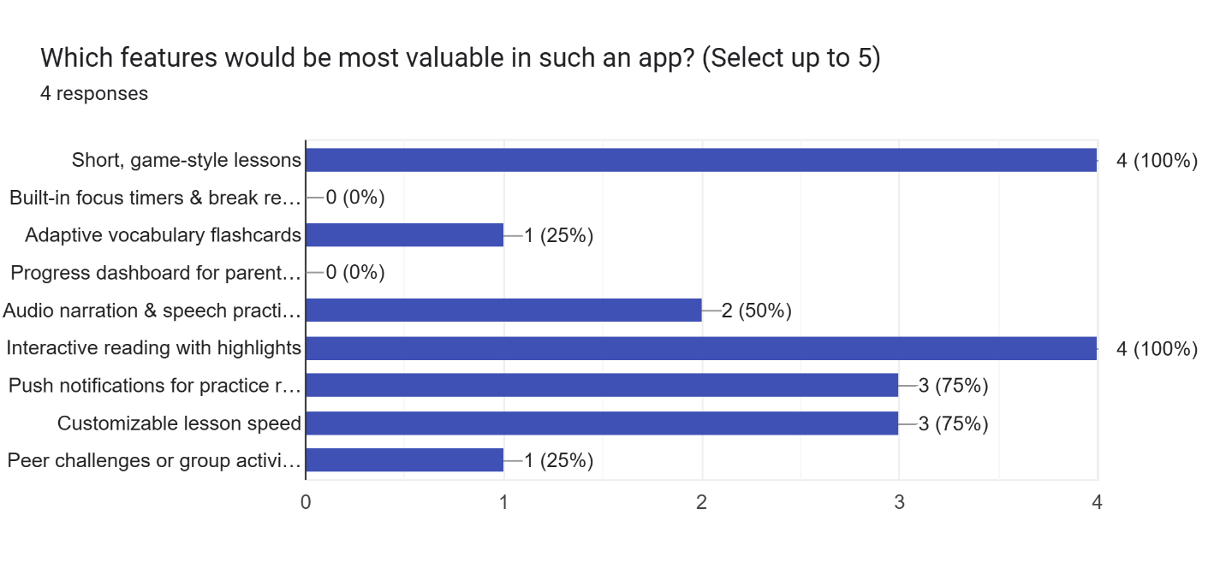

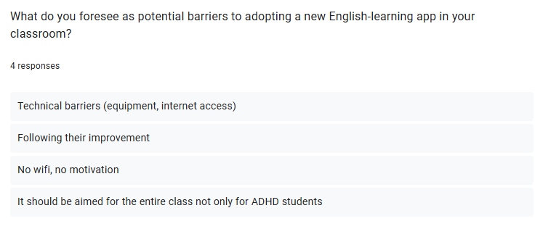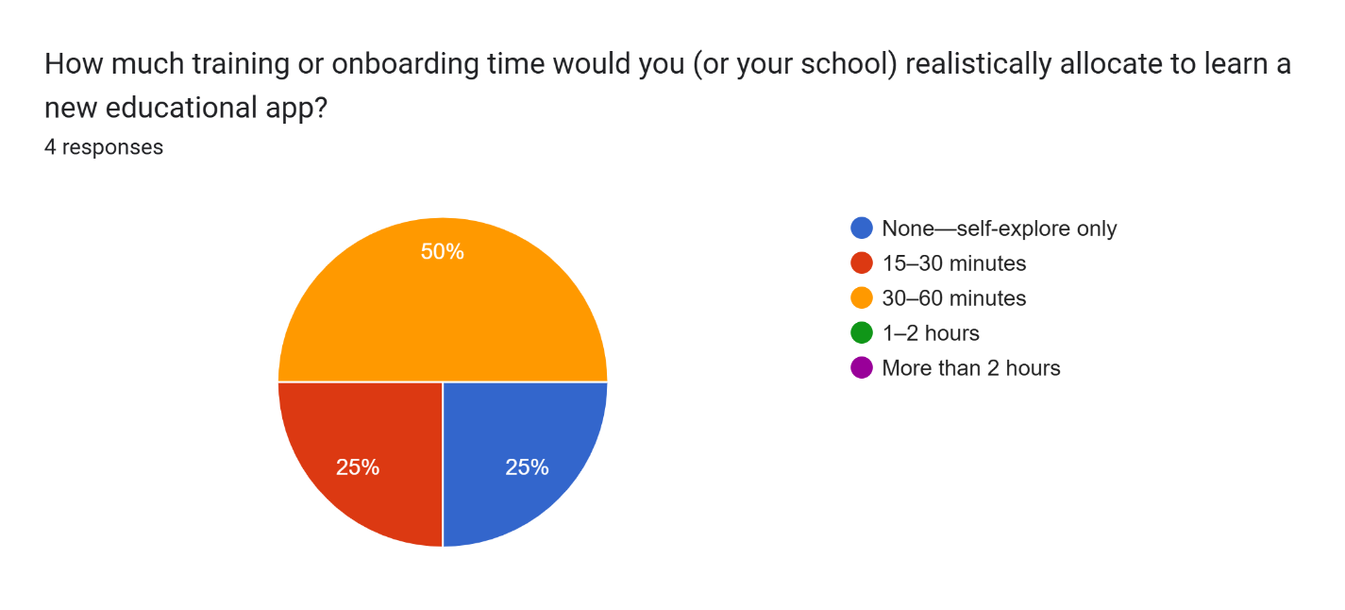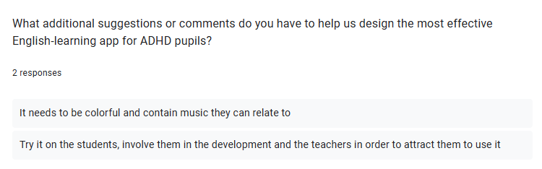

Questionnaire for Parents:
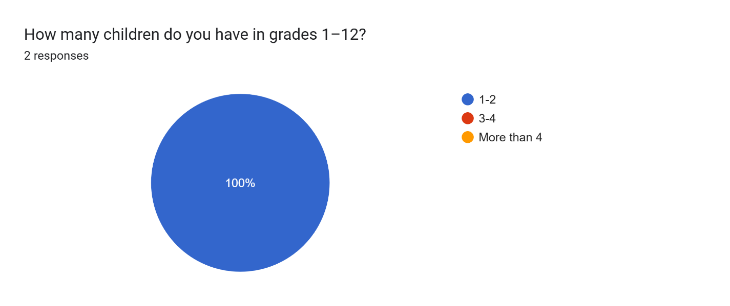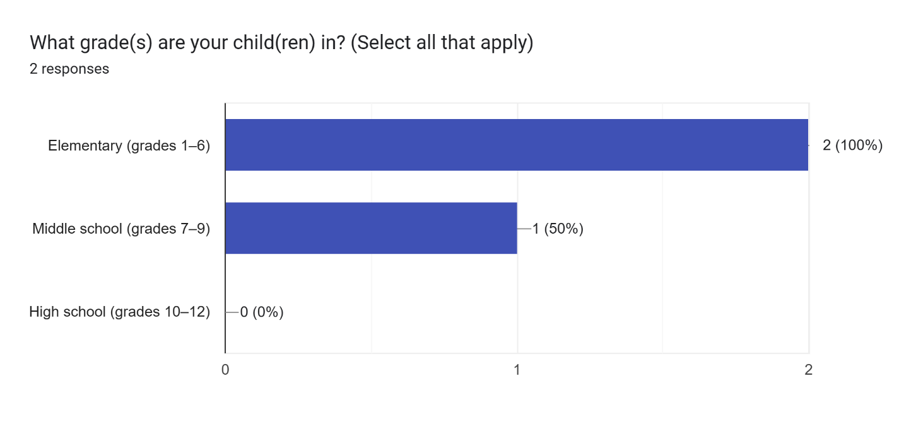
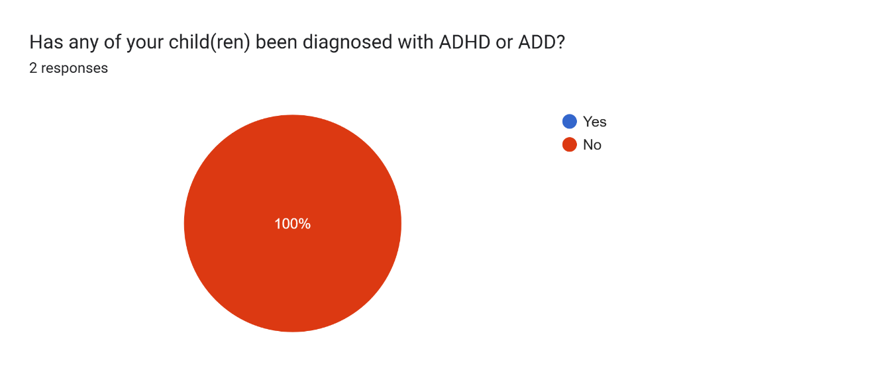
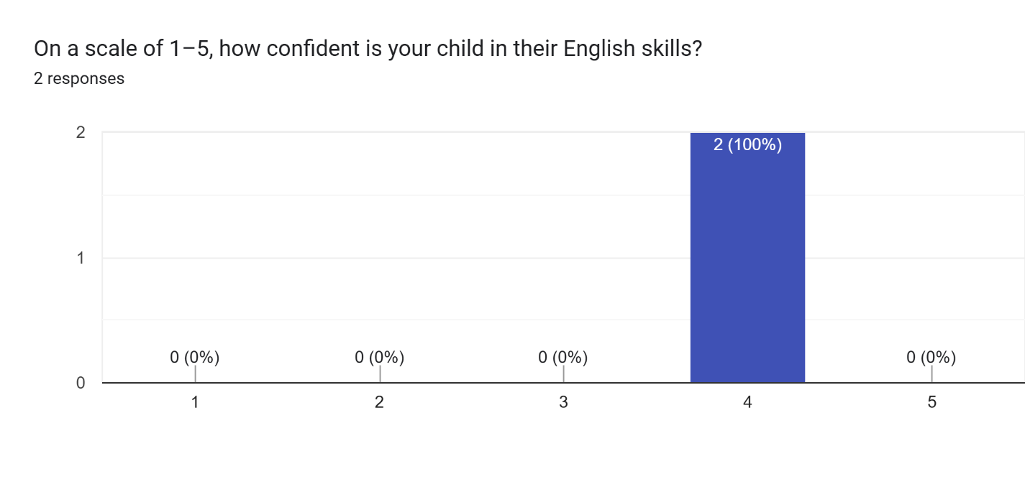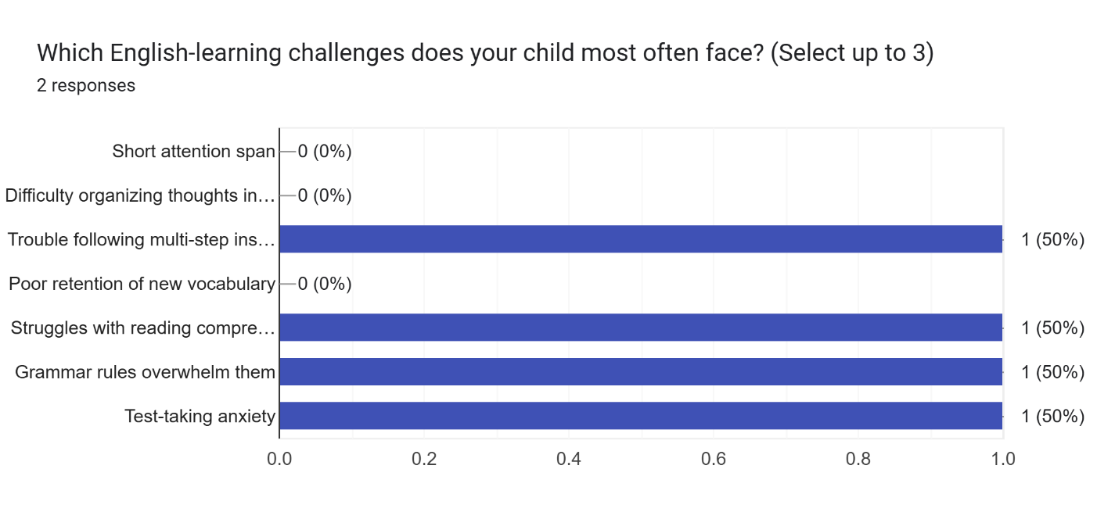
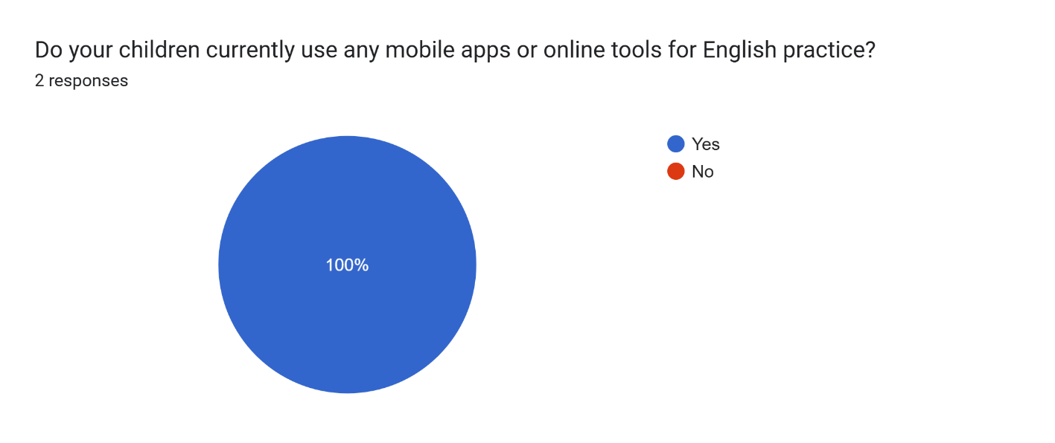
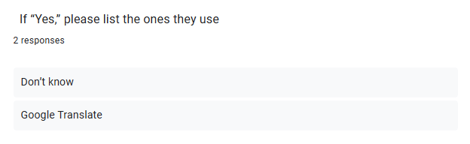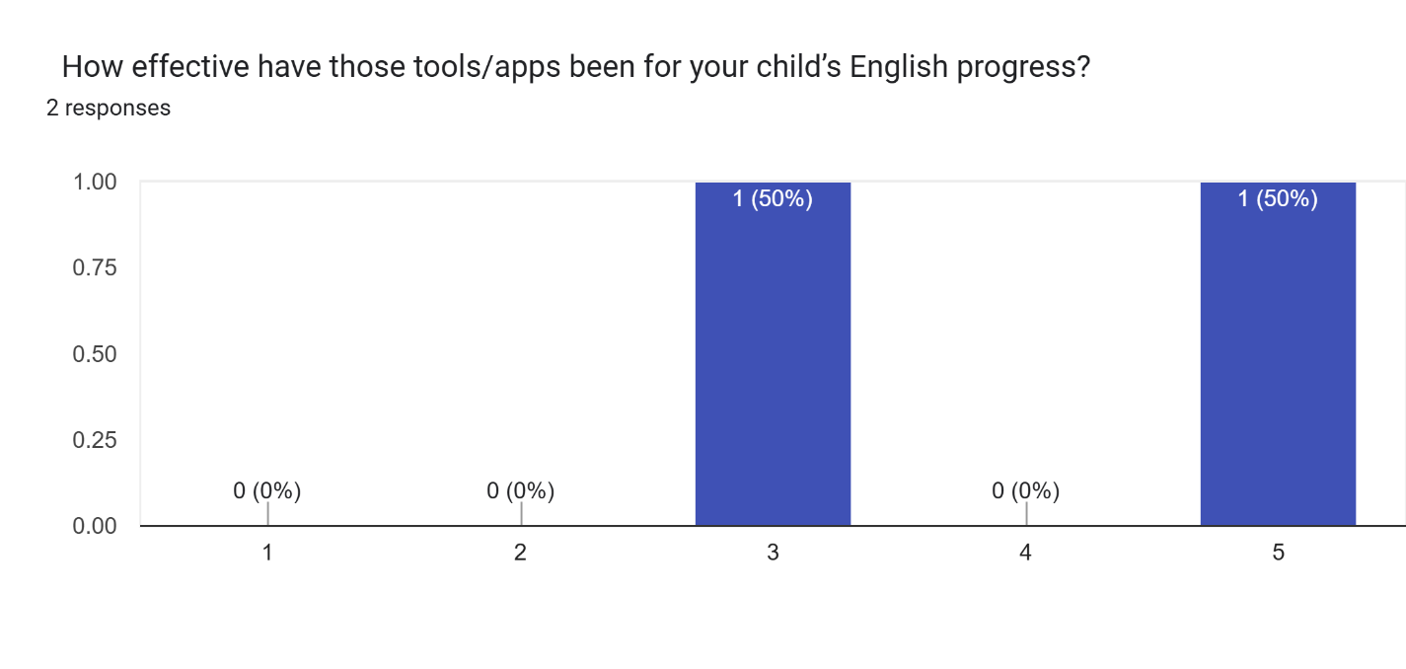
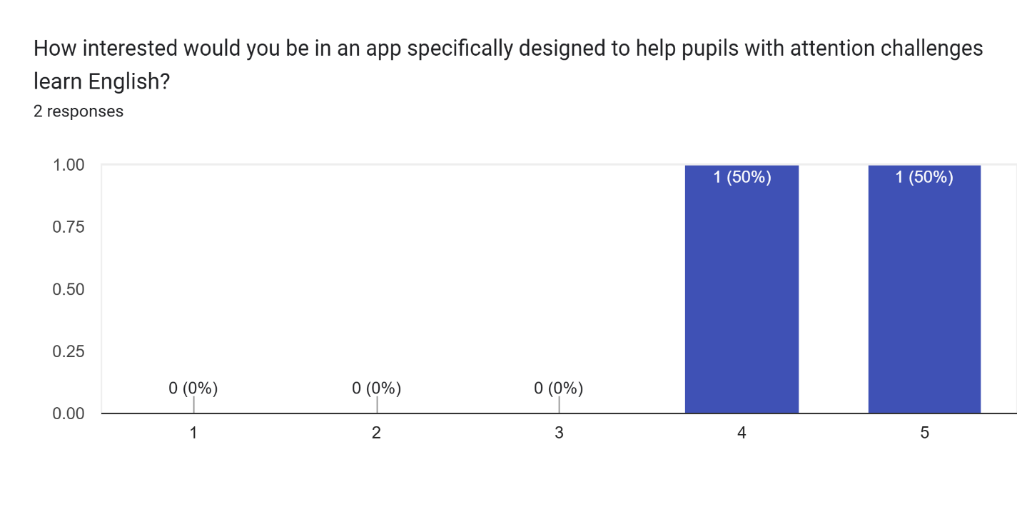
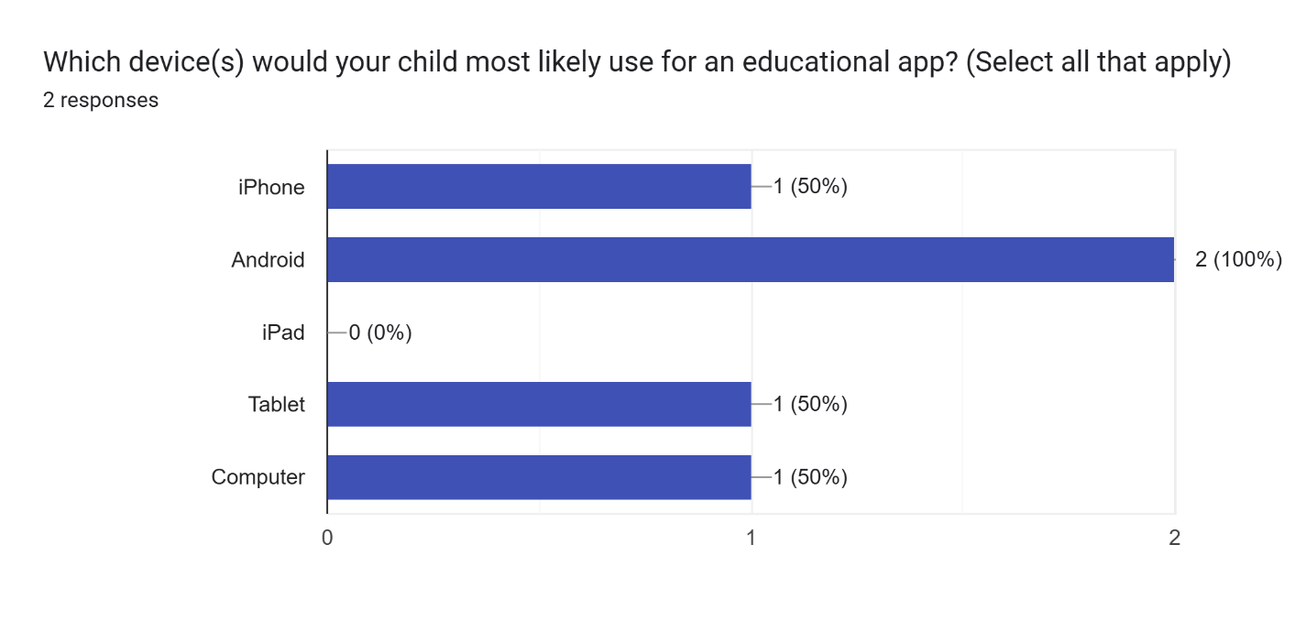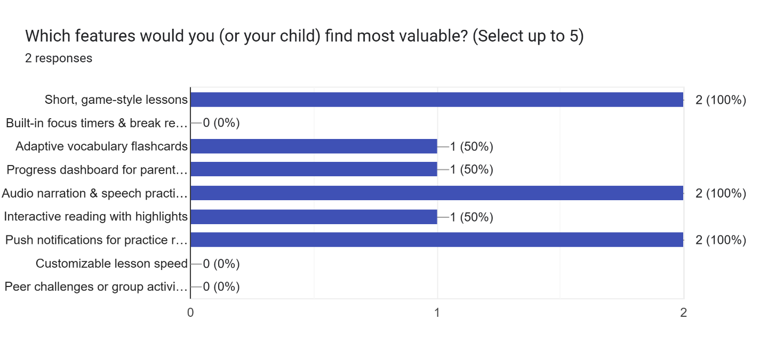

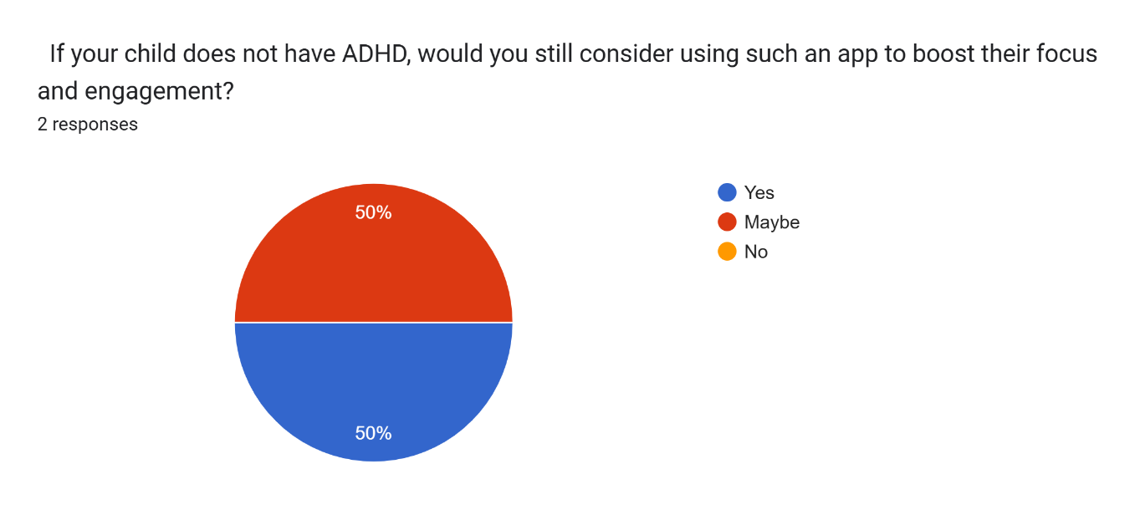
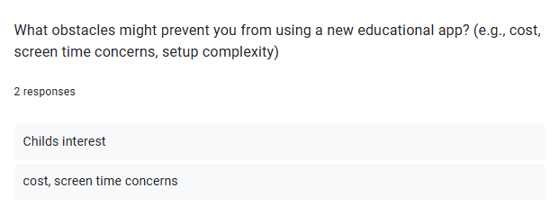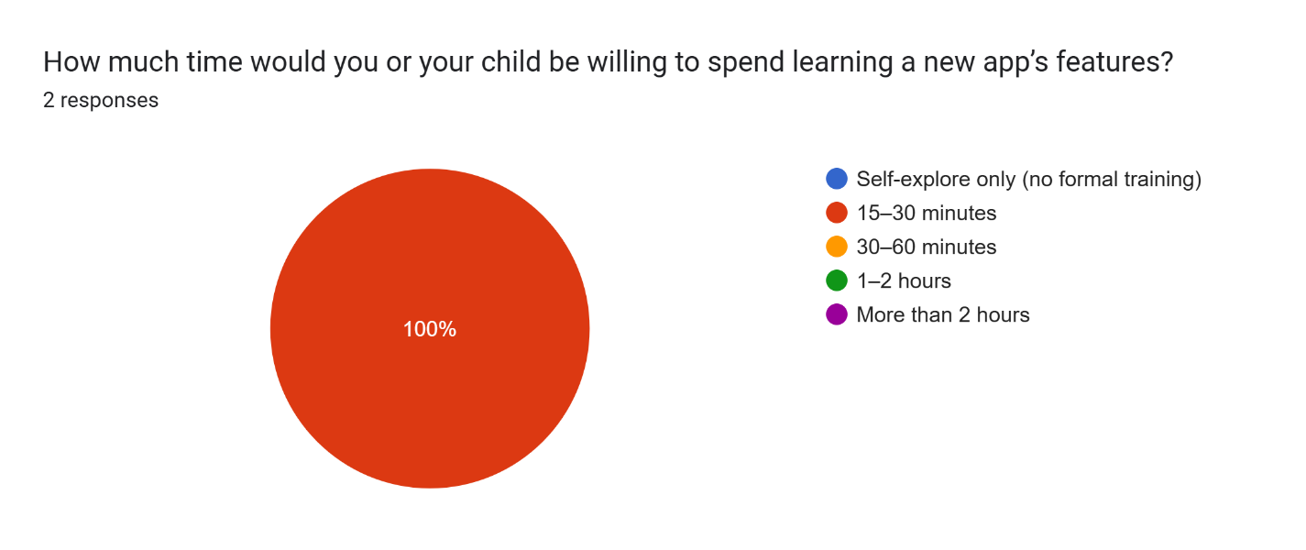
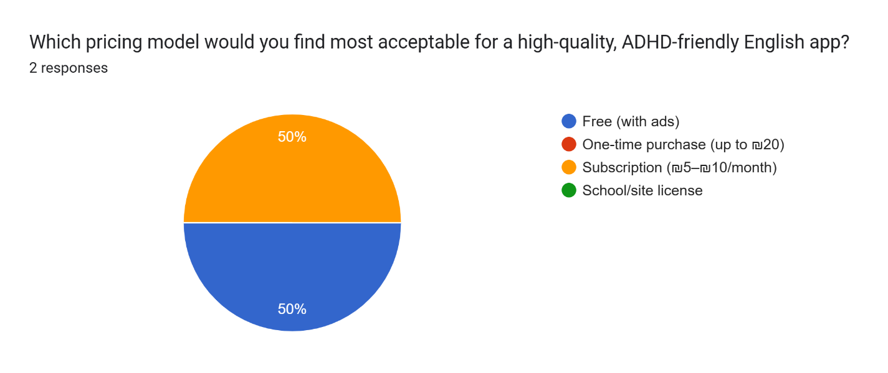

Pupils in grades between first and twelfth.
The Research Files Episode 46: Practical strategies to assist children with ADHD in the classroom
TangiPlan: designing an assistive technology to enhance executive functioning among children with ADHD
WHAAM: A mobile application for ubiquitous monitoring of ADHD behaviors
Snappy App: A Mobile Continuous Performance Test with Physical Activity Measurement for Assessing Attention Decit Hyperactivity Disorder
A longitudinal neuroimaging dataset on arithmetic processing in school children
A content management system (CMS) is a software that helps users create, manage, and modify content on a website without the need for technical knowledge.

